Modern Database Management, 13e (Hoffer)
Chapter 3 The Enhanced E-R Model

1) The property by which subtype entities possess the values of all attributes of a supertype is called:
A) hierarchy reception.
B) class management.
C) multiple inheritance.
D) attribute inheritance.
Answer: D
LO: 3.1: Define key terms.
Difficulty: Moderate
Classification: Concept
AACSB: Information Technology

2) Which of the following is a generic entity type that has a relationship with one or more subtypes?
A) Megatype
B) Supertype
C) Subgroup
D) Class
Answer: B
LO: 3.1: Define key terms.
Difficulty: Easy
Classification: Concept
AACSB: Information Technology

3) Given the following entities, which of the choices below would be the most complicated?

Automobile: VIN, EngineSize, NumberOfDoors, NumberOfPassengers, FuelType, Transmission
SUV: VIN, EngineSize, NumberOfPassengers, NoWheelDrive, FuelType, Transmission
Truck: VIN, EngineSize, NoWheelDrive, FuelType, Transmission, Payload

A) Define one vehicle entity type to hold all entities.
B) Define a separate entity type for each entity.
C) Define a supertype called vehicle and make each of the entities subtypes.
D) Keep only the Truck entity type.
Answer: A
LO: 3.2: Recognize when to use supertype/subtype relationships in data modeling.
Difficulty: Easy
Classification: Concept
AACSB: Information Technology
4) Subtypes should be used when:
A) there are attributes that apply to some but not all instances of an entity type.
B) supertypes relate to objects outside the business.
C) the instances of a subtype do not participate in a relationship that is unique to that subtype.
D) a recursive relationship is needed.
Answer: A
LO: 3.2: Recognize when to use supertype/subtype relationships in data modeling.
Difficulty: Easy
Classification: Concept
AACSB: Information Technology

5) In the figure below, which of the following apply to both OUTPATIENTs and RESIDENT_PATIENTs?

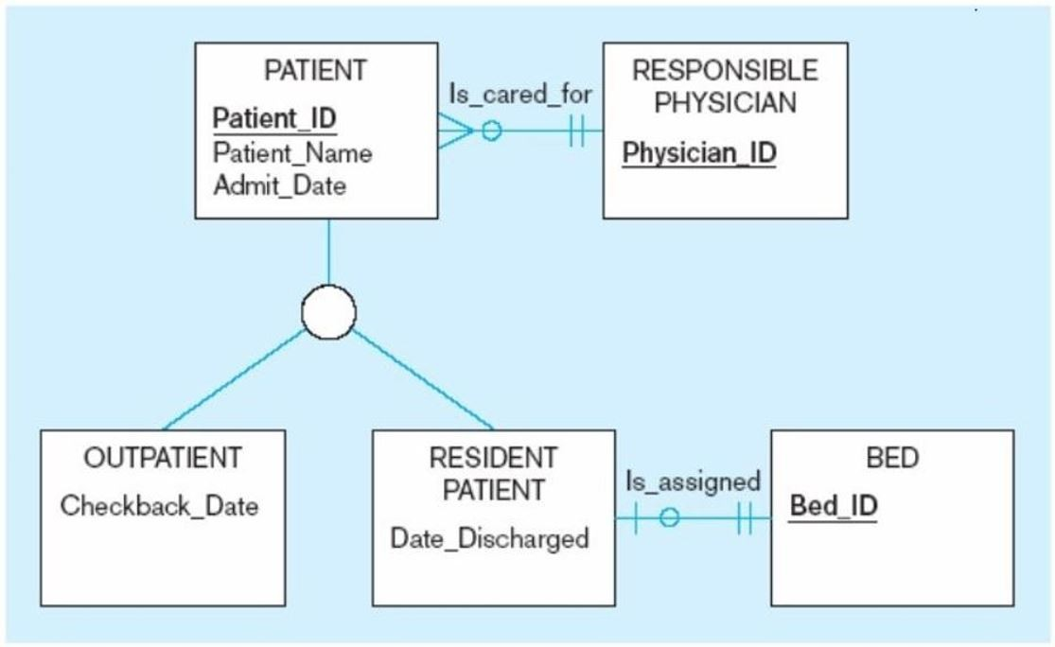

A) Checkback_Date
B) Date_Discharged
C) Patient_Name
D) XML
Answer: C
LO: 3.2: Recognize when to use supertype/subtype relationships in data modeling.
Difficulty: Moderate
Classification: Application
AACSB: Information Technology
6) In the figure below, which of the following is a subtype of patient?

A) Outpatient
B) Physician
C) Bed
D) Date_Hired
Answer: A
LO: 3.2: Recognize when to use supertype/subtype relationships in data modeling.
Difficulty: Moderate
Classification: Application
AACSB: Information Technology

7) The process of defining one or more subtypes of a supertype and forming relationships is called:
A) specialization.
B) generalization.
C) creating discord.
D) selecting classes.
Answer: A
LO: 3.3: Use both specialization and generalization as techniques for defining supertype/ subtype relationships.
Difficulty: Moderate
Classification: Concept
AACSB: Information Technology
8) In the figure below, to which of the following entities are the entities "CAR" and "TRUCK" generalized?

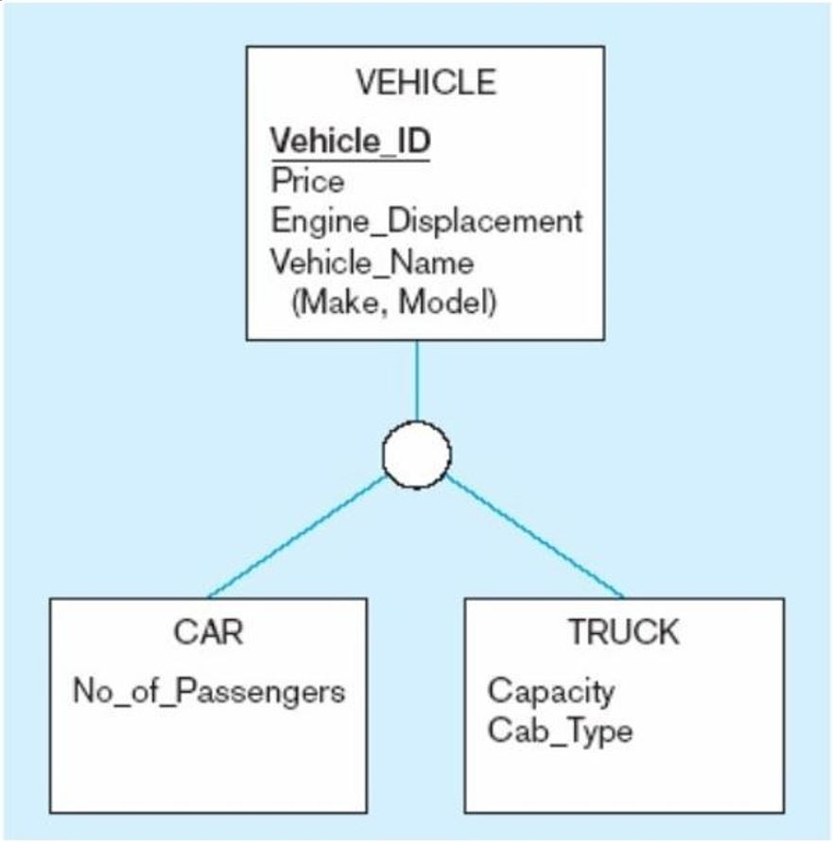

A) Make
B) Vehicle
C) Model
D) Price
Answer: B
LO: 3.3: Use both specialization and generalization as techniques for defining supertype/ subtype relationships.
Difficulty: Moderate
Classification: Application
AACSB: Information Technology
9) The process of defining a more general entity type from a set of more specialized entity types is called:
A) generalization.
B) specialization.
C) normalization.
D) extrapolation.
Answer: A
LO: 3.3: Use both specialization and generalization as techniques for defining supertype/ subtype relationships.
Difficulty: Moderate
Classification: Concept
AACSB: Information Technology

10) The following figure is an example of:

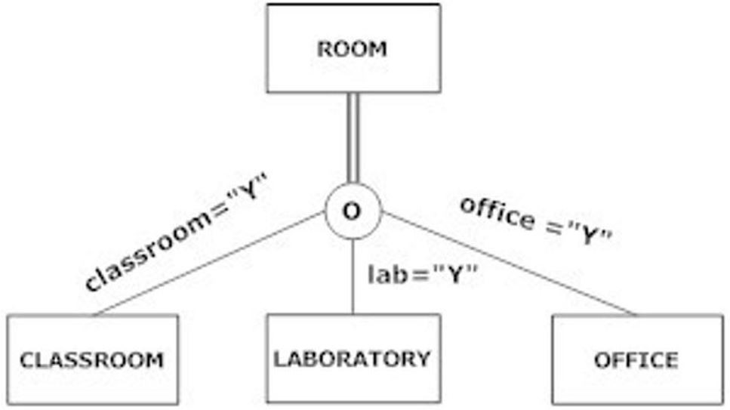

A) partial specialization.
B) completeness.
C) total specialization.
D) disjointness.
Answer: C
LO: 3.3: Use both specialization and generalization as techniques for defining supertype/ subtype relationships.
Difficulty: Easy
Classification: Concept
AACSB: Information Technology
11) The ________ rule specifies that an entity instance of a supertype is allowed not to belong to any subtype.
A) semi-specialization
B) total specialization
C) partial specialization
D) disjointness
Answer: C
LO: 3.3: Use both specialization and generalization as techniques for defining supertype/ subtype relationships.
Difficulty: Moderate
Classification: Concept
AACSB: Information Technology

12) The ________ rule specifies that each entity instance of the supertype must be a member of some subtype in the relationship.
A) semi-specialization
B) total specialization
C) partial specialization
D) total convergence
Answer: B
LO: 3.3: Use both specialization and generalization as techniques for defining supertype/ subtype relationships.
Difficulty: Easy
Classification: Concept
AACSB: Information Technology

13) Which of the following is a completeness constraint?
A) Total specialization
B) Partial generalization
C) Total recall
D) Partial hybridization
Answer: A
LO: 3.4: Specify both completeness constraints and disjointness constraints in modeling.
Difficulty: Easy
Classification: Concept
AACSB: Information Technology

14) A(n) ________ constraint is a type of constraint that addresses whether an instance of a supertype must also be an instance of at least one subtype.
A) disjoint
B) overlap
C) completeness
D) weak
Answer: C
LO: 3.4: Specify both completeness constraints and disjointness constraints in modeling.
Difficulty: Easy
Classification: Concept
AACSB: Information Technology
15) In the figure below, a student:

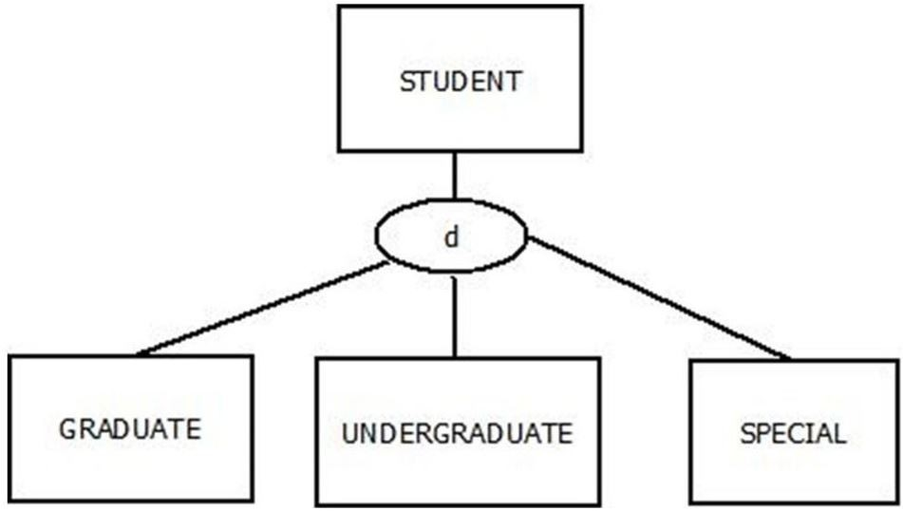

A) must be a graduate student, an undergraduate, a special student or some other type of student.
B) must be a graduate student or an undergraduate student.
C) must be at least a special student.
D) must be a doctoral student.
Answer: A
LO: 3.4: Specify both completeness constraints and disjointness constraints in modeling.
Difficulty: Difficult
Classification: Application
AACSB: Information Technology

16) The ________ rule specifies that an entity can be a member of only one subtype at a time.
A) exclusion
B) disjoint
C) removal
D) inclusion
Answer: B
LO: 3.4: Specify both completeness constraints and disjointness constraints in modeling.
Difficulty: Easy
Classification: Concept
AACSB: Information Technology

17) A ________ addresses whether an instance of a supertype may simultaneously be a member of two or more subtypes.
A) disjointness constraint
B) disjoint rule
C) partial specialization
D) total specialization
Answer: A
LO: 3.4: Specify both completeness constraints and disjointness constraints in modeling.
Difficulty: Easy
Classification: Concept
AACSB: Information Technology
18) In the figure below, the patient must be either an outpatient or a resident patient. This is an example of the ________ rule.

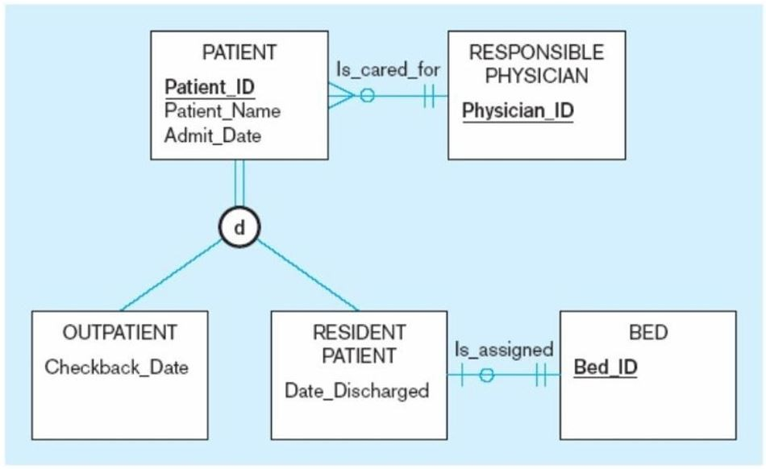

A) disjoint
B) specialization
C) generalization
D) overlap
Answer: A
LO: 3.4: Specify both completeness constraints and disjointness constraints in modeling.
Difficulty: Moderate
Classification: Application
AACSB: Information Technology

19) An attribute of the supertype that determines the target subtype(s) is called the:
A) determinant.
B) subtype decision.
C) disjoint indicator.
D) subtype discriminator.
Answer: D
LO: 3.4: Specify both completeness constraints and disjointness constraints in modeling.
Difficulty: Moderate
Classification: Concept
AACSB: Information Technology
20) The ________ rule states that an entity instance can simultaneously be a member of two (or more) subtypes.
A) disjoint
B) overlap
C) partial specialization
D) total specialization
Answer: B
LO: 3.4: Specify both completeness constraints and disjointness constraints in modeling.
Difficulty: Moderate
Classification: Concept
AACSB: Information Technology

21) The following diagram shows:

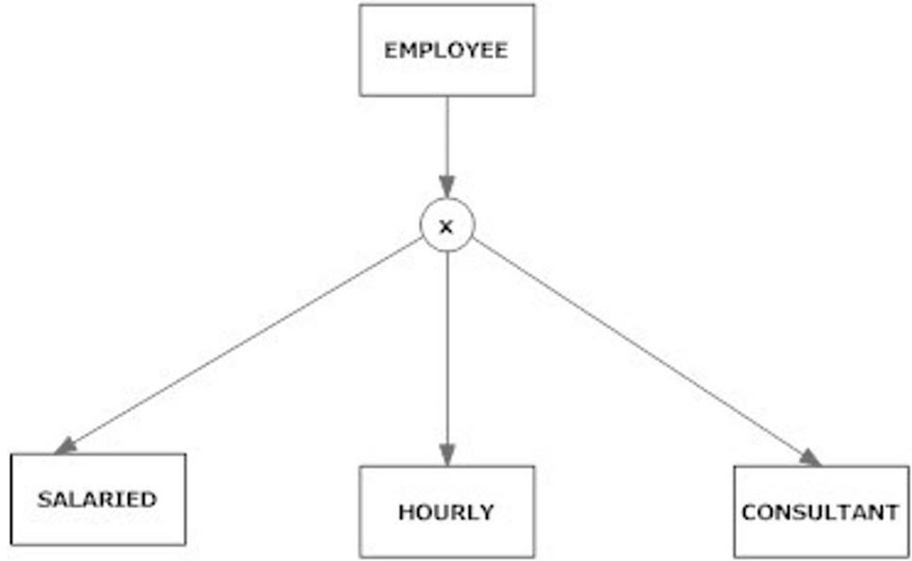

A) total specialization.
B) partial specialization.
C) the overlap rule.
D) subtype discriminator.
Answer: D
LO: 3.4: Specify both completeness constraints and disjointness constraints in modeling.
Difficulty: Moderate
Classification: Application
AACSB: Information Technology
22) The subtype discriminator in the figure below is:

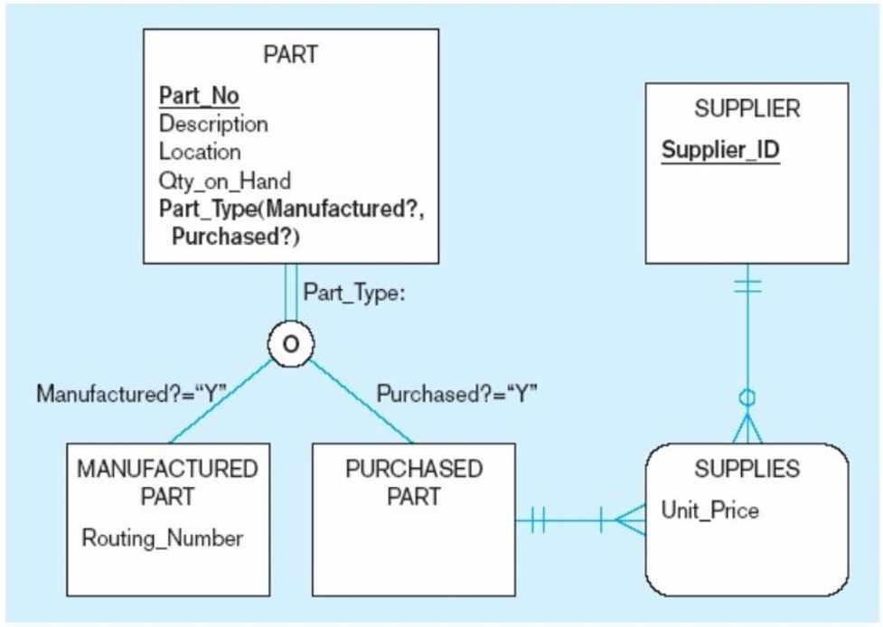

A) Part_Type.
B) Part_No.
C) Manufactured Part.
D) Location.
Answer: A
LO: 3.4: Specify both completeness constraints and disjointness constraints in modeling.
Difficulty: Moderate
Classification: Application
AACSB: Information Technology

23) The subtype discriminator is a composite attribute when there is a(n):
A) overlap rule.
B) disjoint rule.
C) partial specialization.
D) full specialization.
Answer: A
LO: 3.4: Specify both completeness constraints and disjointness constraints in modeling.
Difficulty: Moderate
Classification: Concept
AACSB: Information Technology
24) The following figure shows an example of:

A) the disjoint rule.
B) the completeness rule.
C) the underdog rule.
D) the overlap rule.
Answer: D
LO: 3.4: Specify both completeness constraints and disjointness constraints in modeling.
Difficulty: Moderate
Classification: Application
AACSB: Information Technology

25) In a supertype/subtype hierarchy, each subtype has:
A) only one supertype.
B) many supertypes.
C) at most two supertypes.
D) at least one subtype.
Answer: A
LO: 3.4: Specify both completeness constraints and disjointness constraints in modeling.
Difficulty: Easy
Classification: Concept
AACSB: Information Technology
26) Which of the following statements is true about the figure shown below?

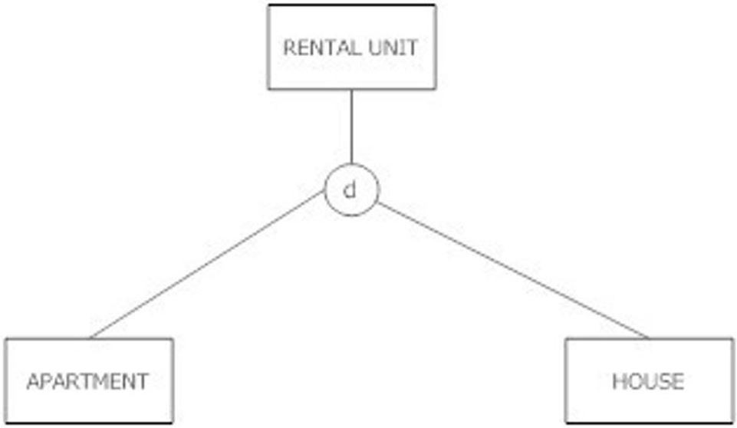

A) A rental unit must be either an apartment or a house, and cannot be both at the same time.
B) A rental unit can be an apartment, house or just a rental unit; it may not be more than one at the same time.
C) A rental unit must be either an apartment or a house, and could be both.
D) A rental unit can be an apartment, a house or just a rental unit. It could be both an apartment and a house at the same time.
Answer: B
LO: 3.5: Develop a supertype/subtype hierarchy for a realistic business situation.
Difficulty: Moderate
Classification: Application
AACSB: Information Technology
27) Which of the following statements is true about the figure shown below?

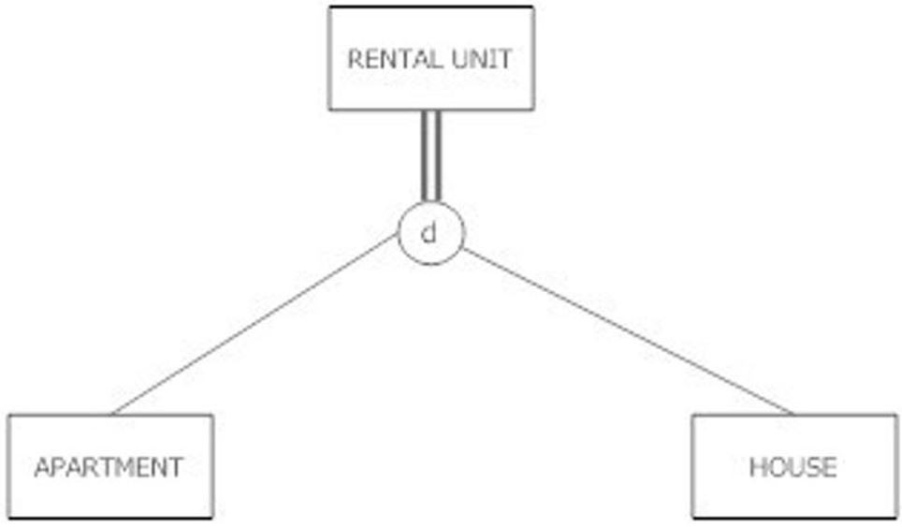

A) A rental unit must be either an apartment or a house, and cannot be both at the same time.
B) A rental unit can be an apartment, house or just a rental unit; it may not be more than one at the same time.
C) A rental unit must be either an apartment or a house, and could be both.
D) A rental unit can be an apartment, a house or just a rental unit. It could be both an apartment and a house at the same time.
Answer: A
LO: 3.5: Develop a supertype/subtype hierarchy for a realistic business situation.
Difficulty: Moderate
Classification: Application
AACSB: Information Technology
28) Which of the following statements is true about the figure shown below?

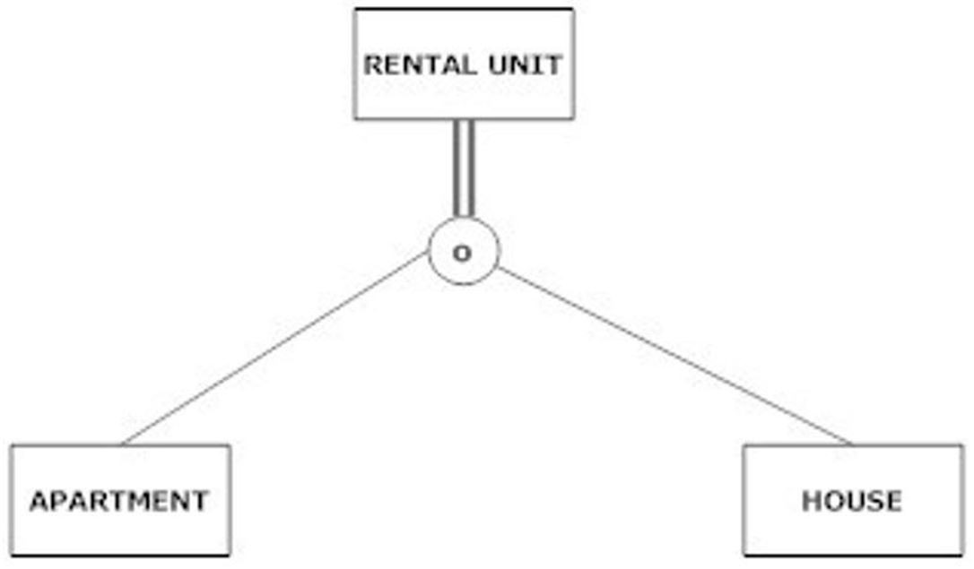

A) A rental unit must be either an apartment or a house, and cannot be both at the same time.
B) A rental unit can be an apartment, house or just a rental unit; it may not be more than one at the same time.
C) A rental unit must be either an apartment or a house, and could be both.
D) A rental unit can be an apartment, a house or just a rental unit. It could be both an apartment and a house at the same time.
Answer: C
LO: 3.5: Develop a supertype/subtype hierarchy for a realistic business situation.
Difficulty: Moderate
Classification: Application
AACSB: Information Technology
29) Which of the following statements is true about the figure shown below?

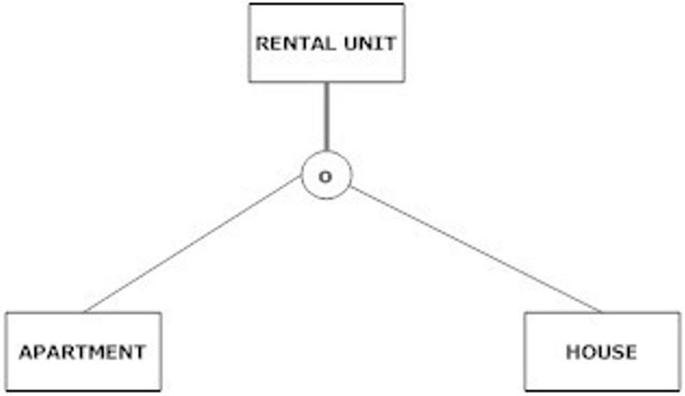

A) A rental unit must be either an apartment or a house, and cannot be both at the same time.
B) A rental unit can be an apartment, house or just a rental unit; it may not be more than one at the same time.
C) A rental unit must be either an apartment or a house, and could be both.
D) A rental unit can be an apartment, a house or just a rental unit. It could be both an apartment and a house at the same time.
Answer: D
LO: 3.5: Develop a supertype/subtype hierarchy for a realistic business situation.
Difficulty: Moderate
Classification: Application
AACSB: Information Technology

30) In a supertype/subtype hierarchy, subtypes that are lower in the hierarchy inherit attributes from not only their immediate supertype but from all ________ in the hierarchy.
A) subtypes
B) supertypes
C) constraints
D) dimensions
Answer: B
LO: 3.5: Develop a supertype/subtype hierarchy for a realistic business situation.
Difficulty: Moderate
Classification: Concept
AACSB: Information Technology
31) The following figure shows a:

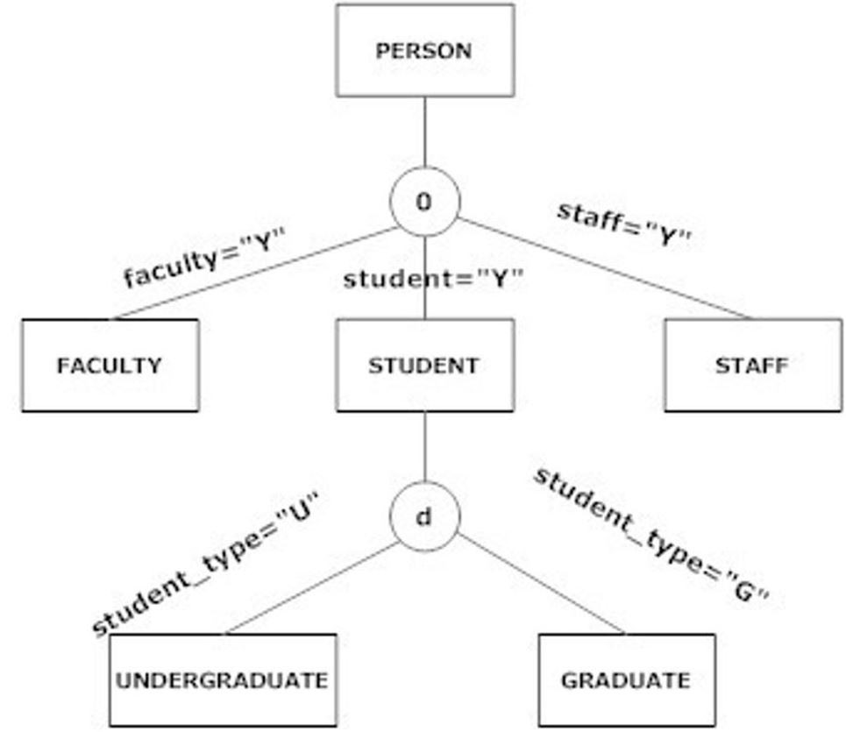

A) disjoint constraint.
B) completeness constraint.
C) supertype/subtype hierarchy.
D) spindle constraint.
Answer: C
LO: 3.5: Develop a supertype/subtype hierarchy for a realistic business situation.
Difficulty: Moderate
Classification: Application
AACSB: Information Technology
32) Which statement is true about the following diagram?

A) A person can only be a faculty, student, or staff.
B) A student can be both an undergraduate and a graduate student at the same time.
C) All attributes of person and student are inherited by undergraduate.
D) All attributes of graduate are inherited by person.
Answer: A
LO: 3.5: Develop a supertype/subtype hierarchy for a realistic business situation.
Difficulty: Moderate
Classification: Application
AACSB: Information Technology

33) An entity cluster is:
A) a formal method for specifying attributes of related entities.
B) a set of one or more entity types and associated relationships grouped into a single abstract entity type.
C) a useful way to present data for a small and fairly simple organization.
D) a way of developing more granular views of the data model.
Answer: B
LO: 3.6: Develop an entity cluster to simplify presentation of an E-R diagram.
Difficulty: Moderate
Classification: Concept
AACSB: Information Technology
34) The figure below is an example of a(n):

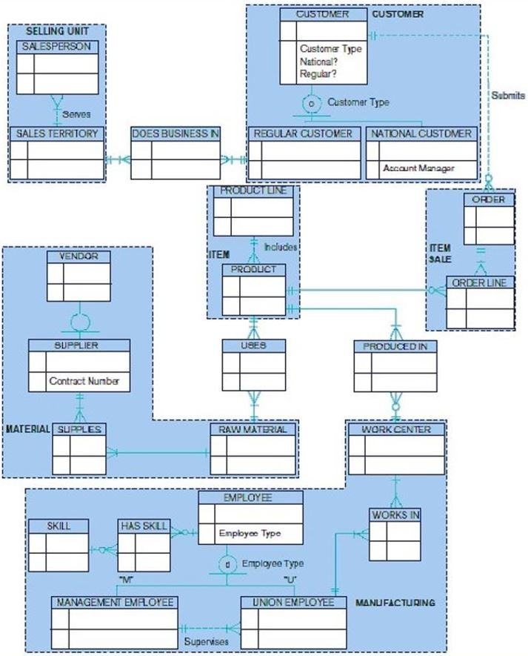

A) supertype/subtype hierarchy.
B) hierarchical data model.
C) entity cluster.
D) column cluster.
Answer: C
LO: 3.6: Develop an entity cluster to simplify presentation of an E-R diagram.
Difficulty: Moderate
Classification: Application
AACSB: Information Technology

35) An entity cluster can be formed by:
A) deleting a supertype and its subtype.
B) combining metadata.
C) combining a strong entity and its weak entities.
D) deleting metadata.
Answer: C
LO: 3.6: Develop an entity cluster to simplify presentation of an E-R diagram.
Difficulty: Easy
Classification: Concept
AACSB: Information Technology

36) Packaged data models:
A) are ready to use right out of the box.
B) require customization.
C) allow partial specialization.
D) cannot be used for most applications.
Answer: B
LO: 3.7: Explain the major features and data modeling structures of a universal (packaged) data model.
Difficulty: Easy
Classification: Concept
AACSB: Information Technology

37) Which of the following is true of packaged data models?
A) Relationships are connected to the highest-level entity type in an order that makes sense.
B) All subtype/supertype relationships follow the total specialization and disjoint rules.
C) No entities on the many sides of a relationship can be weak.
D) All weak entities are considered strong.
Answer: A
LO: 3.7: Explain the major features and data modeling structures of a universal (packaged) data model.
Difficulty: Difficult
Classification: Concept
AACSB: Information Technology

38) A generic or template data model that can be reused as a starting point for a data modeling project is called a(n):
A) packaged data model.
B) universal data model.
C) enterprise data model.
D) collection data model.
Answer: B
LO: 3.7: Explain the major features and data modeling structures of a universal (packaged) data model.
Difficulty: Difficult
Classification: Concept
AACSB: Information Technology
39) Using a packaged data model, projects take less time and cost because:
A) less personnel are required.
B) essential components and structures are already defined.
C) there is more time taken to model the enterprise.
D) packaged data models only run in Oracle.
Answer: B
LO: 3.7: Explain the major features and data modeling structures of a universal (packaged) data model.
Difficulty: Moderate
Classification: Concept
AACSB: Information Technology

40) All of the following are advantages of packaged data models EXCEPT:
A) packaged data models can be built using proven components evolved from cumulative experiences.
B) projects take less time and cost less.
C) the data model is easier to evolve.
D) more one-to-one relationships give the data model more flexibility.
Answer: D
LO: 3.7: Explain the major features and data modeling structures of a universal (packaged) data model.
Difficulty: Easy
Classification: Concept
AACSB: Information Technology

41) All of the following are steps to using a packaged data model EXCEPT:
A) identify the parts of the data model that apply to your data modeling situation.
B) utilize all business rules that come with the packaged data model.
C) rename the identified data elements.
D) map data to be used in packages with existing data in the current databases.
Answer: B
LO: 3.7: Explain the major features and data modeling structures of a universal (packaged) data model.
Difficulty: Difficult
Classification: Concept
AACSB: Information Technology

42) When identifying the parts of the packaged data model that apply to your organization, one should first start with:
A) entities.
B) attributes.
C) primary keys.
D) relationships.
Answer: A
LO: 3.7: Explain the major features and data modeling structures of a universal (packaged) data model.
Difficulty: Moderate
Classification: Concept
AACSB: Information Technology
43) The third step in the data modeling process with a packaged data model is:
A) rename identified data elements.
B) rename relationships.
C) map data to be used from package to data in current databases.
D) interview users.
Answer: C
LO: 3.7: Explain the major features and data modeling structures of a universal (packaged) data model.
Difficulty: Easy
Classification: Concept
AACSB: Information Technology

44) A good method for identifying inconsistencies and finding hidden meaning in the customized purchased data model is:
A) data analysis.
B) data volume usage analysis.
C) user interviews.
D) data profiling.
Answer: D
LO: 3.8: Describe the special features of a data modeling project when using a packaged data model.
Difficulty: Moderate
Classification: Concept
AACSB: Information Technology

45) The most important challenge of customizing a purchased data model is:
A) getting user buy-in.
B) determining the business rules that will be established through the data model.
C) implementation.
D) user training.
Answer: B
LO: 3.8: Describe the special features of a data modeling project when using a packaged data model.
Difficulty: Moderate
Classification: Concept
AACSB: Information Technology

46) In packaged data models, strong entities always have ________ between them.
A) weak entities
B) 1:1 relationships
C) 1:M relationships
D) M:N relationships
Answer: D
LO: 3.8: Describe the special features of a data modeling project when using a packaged data model.
Difficulty: Difficult
Classification: Concept
AACSB: Information Technology
47) In packaged data models, all subtype/supertype relationships follow the ________ and ________ rules.
A) partial specialization; disjoint
B) total specialization; disjoint
C) total specialization; overlap
D) partial specialization; overlap
Answer: C
LO: 3.8: Describe the special features of a data modeling project when using a packaged data model.
Difficulty: Moderate
Classification: Concept
AACSB: Information Technology

48) A subtype is a generic entity that has a relationship with one or more entities at a lower level.
Answer: FALSE
LO: 3.1: Define key terms.
Difficulty: Easy
Classification: Concept
AACSB: Information Technology

49) An entity instance of a subtype represents the same entity instance of the supertype.
Answer: TRUE
LO: 3.1: Define key terms.
Difficulty: Moderate
Classification: Concept
AACSB: Information Technology

50) A member of a subtype does NOT necessarily have to be a member of the supertype.
Answer: FALSE
LO: 3.1: Define key terms.
Difficulty: Moderate
Classification: Concept
AACSB: Information Technology

51) Supertype/subtype relationships should not be used when the instances of a subtype participate in no relationships which are unique to that subtype.
Answer: TRUE
LO: 3.2: Recognize when to use supertype/subtype relationships in data modeling.
Difficulty: Moderate
Classification: Concept
AACSB: Information Technology

52) One of the major challenges in data modeling is to recognize and clearly represent entities that are almost the same.
Answer: TRUE
LO: 3.2: Recognize when to use supertype/subtype relationships in data modeling.
Difficulty: Difficult
Classification: Concept
AACSB: Information Technology
53) The following figure is an example of total specialization.

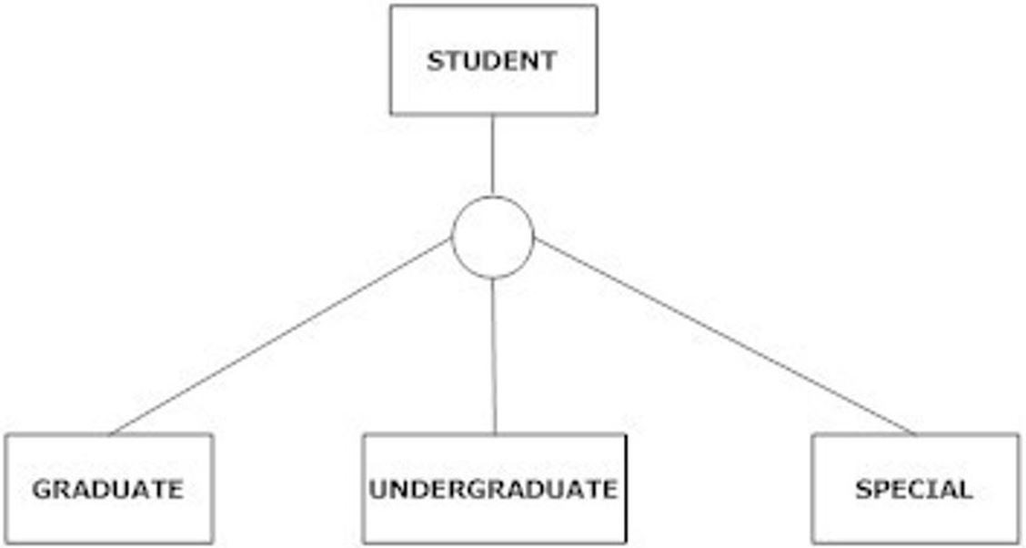

Answer: FALSE
LO: 3.2: Recognize when to use supertype/subtype relationships in data modeling.
Difficulty: Difficult
Classification: Concept
AACSB: Information Technology

54) Specialization is the reverse of generalization.
Answer: TRUE
LO: 3.3: Use both specialization and generalization as techniques for defining supertype/ subtype relationships.
Difficulty: Moderate
Classification: Concept
AACSB: Information Technology

55) The total specialization rule states that an entity instance of a supertype is allowed not to belong to any subtype.
Answer: FALSE
LO: 3.3: Use both specialization and generalization as techniques for defining supertype/ subtype relationships.
Difficulty: Moderate
Classification: Concept
AACSB: Information Technology

56) Generalization is a top-down process.
Answer: FALSE
LO: 3.3: Use both specialization and generalization as techniques for defining supertype/ subtype relationships.
Difficulty: Easy
Classification: Concept
AACSB: Information Technology
57) A completeness constraint may specify that each entity of the supertype must be a member of some subtype in the relationship.
Answer: TRUE
LO: 3.4: Specify both completeness constraints and disjointness constraints in modeling.
Difficulty: Easy
Classification: Concept
AACSB: Information Technology

58) When the total specialization rule is set for a supertype/subtype relationship, one could roughly compare the supertype to an abstract class in object-oriented programming.
Answer: FALSE
LO: 3.4: Specify both completeness constraints and disjointness constraints in modeling.
Difficulty: Difficult
Classification: Concept
AACSB: Information Technology

59) The disjoint rule specifies that if an entity instance of the supertype is a member of one subtype, it MUST simultaneously be a member of another subtype.
Answer: FALSE
LO: 3.4: Specify both completeness constraints and disjointness constraints in modeling.
Difficulty: Moderate
Classification: Concept
AACSB: Information Technology

60) The overlap rule specifies that if an entity instance of the supertype is a member of one subtype, it can simultaneously be a member of two (or more) subtypes.
Answer: TRUE
LO: 3.4: Specify both completeness constraints and disjointness constraints in modeling.
Difficulty: Moderate
Classification: Concept
AACSB: Information Technology
61) The following figure is an example of the overlap rule.

Answer: FALSE
LO: 3.4: Specify both completeness constraints and disjointness constraints in modeling.
Difficulty: Moderate
Classification: Concept
AACSB: Information Technology

62) When subtypes are overlapping, an additional field must be added to the supertype to act as a discriminator.
Answer: FALSE
LO: 3.4: Specify both completeness constraints and disjointness constraints in modeling.
Difficulty: Difficult
Classification: Concept
AACSB: Information Technology
63) There are three separate discriminators in the following diagram because of the overlap rule.

Answer: TRUE
LO: 3.4: Specify both completeness constraints and disjointness constraints in modeling.
Difficulty: Moderate
Classification: Concept
AACSB: Information Technology

64) A subtype can become a supertype if the subtype has other subtypes beneath it.
Answer: TRUE
LO: 3.4: Specify both completeness constraints and disjointness constraints in modeling.
Difficulty: Moderate
Classification: Concept
AACSB: Information Technology
65) The following diagram is an example of a supertype/subtype hierarchy.

Answer: TRUE
LO: 3.4: Specify both completeness constraints and disjointness constraints in modeling.
Difficulty: Moderate
Classification: Concept
AACSB: Information Technology

66) In a supertype/subtype hierarchy, attributes are assigned at the highest logical level that is possible in the hierarchy.
Answer: TRUE
LO: 3.4: Specify both completeness constraints and disjointness constraints in modeling.
Difficulty: Moderate
Classification: Concept
AACSB: Information Technology

67) Subtypes at the lowest level of a hierarchy do not inherit attributes from their ancestors.
Answer: FALSE
LO: 3.4: Specify both completeness constraints and disjointness constraints in modeling.
Difficulty: Moderate
Classification: Concept
AACSB: Information Technology
68) In the figure shown below, a rental unit can be both a house and an apartment.

Answer: FALSE
LO: 3.5: Develop a supertype/subtype hierarchy for a realistic business situation.
Difficulty: Moderate
Classification: Application
AACSB: Information Technology

69) In the figure shown below, a rental unit has to be either a house or an apartment.

Answer: TRUE
LO: 3.5: Develop a supertype/subtype hierarchy for a realistic business situation.
Difficulty: Moderate
Classification: Application
AACSB: Information Technology
70) In the figure shown below, there could be an instance of a rental unit that is neither an apartment nor a house.

Answer: TRUE
LO: 3.5: Develop a supertype/subtype hierarchy for a realistic business situation.
Difficulty: Moderate
Classification: Application
AACSB: Information Technology

71) In the figure shown below, a rental unit can be both an apartment and a house but must be at least one.

Answer: FALSE
LO: 3.5: Develop a supertype/subtype hierarchy for a realistic business situation.
Difficulty: Moderate
Classification: Application
AACSB: Information Technology
72) Regardless of the business situation, a member of the supertype is always a member of more than one subtype.
Answer: FALSE
LO: 3.5: Develop a supertype/subtype hierarchy for a realistic business situation.
Difficulty: Difficult
Classification: Concept
AACSB: Information Technology

73) Entity clustering is a methodology for grouping one or more entity types and associated relationships into a single abstract entity type.
Answer: TRUE
LO: 3.6: Develop an entity cluster to simplify presentation of an E-R diagram.
Difficulty: Easy
Classification: Concept
AACSB: Information Technology

74) An entity cluster should focus on some area of interest to some community of users, developers, or managers.
Answer: TRUE
LO: 3.6: Develop an entity cluster to simplify presentation of an E-R diagram.
Difficulty: Moderate
Classification: Concept
AACSB: Information Technology

75) An entity cluster can have a relationship with another entity cluster much the same way that an entity can have a relationship with another entity.
Answer: TRUE
LO: 3.6: Develop an entity cluster to simplify presentation of an E-R diagram.
Difficulty: Moderate
Classification: Concept
AACSB: Information Technology

76) Packaged data models are meant to be customized.
Answer: TRUE
LO: 3.7: Explain the major features and data modeling structures of a universal (packaged) data model.
Difficulty: Easy
Classification: Concept
AACSB: Information Technology

77) Packaged data models use an entity type to store union data.
Answer: FALSE
LO: 3.7: Explain the major features and data modeling structures of a universal (packaged) data model.
Difficulty: Moderate
Classification: Concept
AACSB: Information Technology

78) A universal data model is a generic or template data model that can be reused as a starting point for a data modeling project.
Answer: TRUE
LO: 3.7: Explain the major features and data modeling structures of a universal (packaged) data model.
Difficulty: Moderate
Classification: Concept
AACSB: Information Technology
79) Packaged data models cause projects to take more time to build.
Answer: FALSE
LO: 3.7: Explain the major features and data modeling structures of a universal (packaged) data model.
Difficulty: Moderate
Classification: Concept
AACSB: Information Technology

80) Packaged data models can be developed using proven components.
Answer: TRUE
LO: 3.7: Explain the major features and data modeling structures of a universal (packaged) data model.
Difficulty: Moderate
Classification: Concept
AACSB: Information Technology

81) Data models of an existing database are harder for data modelers to read.
Answer: FALSE
LO: 3.7: Explain the major features and data modeling structures of a universal (packaged) data model.
Difficulty: Moderate
Classification: Concept
AACSB: Information Technology

82) Packaged data models are as flexible as possible, because all supertype/subtype relationships allow the total specialization and overlap rules.
Answer: TRUE
LO: 3.7: Explain the major features and data modeling structures of a universal (packaged) data model.
Difficulty: Easy
Classification: Concept
AACSB: Information Technology

83) Creating a data model from a packaged data model requires much more skill than creating one from scratch.
Answer: FALSE
LO: 3.7: Explain the major features and data modeling structures of a universal (packaged) data model.
Difficulty: Easy
Classification: Concept
AACSB: Information Technology

84) It is easier to share information across organizations if companies in the same industry use the same universal data model as the basis for their organizational databases.
Answer: TRUE
LO: 3.7: Explain the major features and data modeling structures of a universal (packaged) data model.
Difficulty: Moderate
Classification: Concept
AACSB: Information Technology

85) Adapting a packaged data model from your DBMS vendor makes it difficult for the application to work with other applications from the same vendor.
Answer: FALSE
LO: 3.7: Explain the major features and data modeling structures of a universal (packaged) data model.
Difficulty: Moderate
Classification: Concept
AACSB: Information Technology
86) Because a purchased data model is extensive, you begin by identifying the parts of the data model that apply to your data modeling situation.
Answer: TRUE
LO: 3.7: Explain the major features and data modeling structures of a universal (packaged) data model.
Difficulty: Moderate
Classification: Concept
AACSB: Information Technology

87) You will never need to map data in current databases to data in a packaged data model.
Answer: FALSE
LO: 3.7: Explain the major features and data modeling structures of a universal (packaged) data model.
Difficulty: Moderate
Classification: Concept
AACSB: Information Technology

88) Mapping existing data to new data in a packaged data model is useful for developing migration plans.
Answer: TRUE
LO: 3.8: Describe the special features of a data modeling project when using a packaged data model.
Difficulty: Moderate
Classification: Concept
AACSB: Information Technology

89) It is easy to miss the opportunity to visualize future requirements shown in the full data model when using a packaged data model.
Answer: TRUE
LO: 3.8: Describe the special features of a data modeling project when using a packaged data model.
Difficulty: Moderate
Classification: Concept
AACSB: Information Technology

90) The most important challenge of customizing a purchased data model is determining the business rules that will be established through the data model.
Answer: TRUE
LO: 3.8: Describe the special features of a data modeling project when using a packaged data model.
Difficulty: Difficult
Classification: Concept
AACSB: Information Technology

91) Explain why the E-R model needed to be expanded into the enhanced E-R model.
Answer: The business environment has drastically changed since the relational model was first introduced in the 1970s. Business relationships are more complex, and organizations must have ways to represent data to represent the complexity. Organizations must be prepared to segment their markets as well as customize their products. The enhanced E-R model has evolved to represent these changes and also is similar to the object-oriented data model.
LO: 3.1: Define key terms.
Difficulty: Moderate
Classification: Synthesis
AACSB: Reflective Thinking
92) Explain the terms subtype and supertype. Discuss the differences between them.
Answer: A subtype is an entity which represents data meaningful to the organization. For example, an undergraduate student and a graduate student might be a subtype. A supertype is a generalization of various subtypes and contains attributes which are common to both. Supertypes and subtypes may have relationships with other entities. Also, a subtype inherits the attributes of its supertype.
LO: 3.2: Recognize when to use supertype/subtype relationships in data modeling.
Difficulty: Moderate
Classification: Synthesis
AACSB: Reflective Thinking

93) Discuss the reasoning behind using supertype/subtype relationships.
Answer: It is best to use a supertype/subtype hierarchy when there are attributes that apply to some but not all instances of an entity type. For example, if we have an employee entity type and there is an hourly wage attribute that only applies to hourly employees, it may be best to use a supertype/subtype relationship. Another reason for using supertype/subtype relationships is when you have instances of a subtype that participate in a relationship unique to that subtype. For example, if we have a contractor subtype of employee that has a relationship with staffing agency, then it would be best to use supertype/subtype relationship.
LO: 3.2: Recognize when to use supertype/subtype relationships in data modeling.
Difficulty: Moderate
Classification: Synthesis
AACSB: Reflective Thinking

94) Compare and contrast generalization and specialization.
Answer: Generalization is the process of defining a more general entity type from a set of more specialized entity types. For example, if we had undergraduate and graduate students with similar attributes, then we might create a student supertype. The student supertype would then contain the attributes that all subtypes have in common. Specialization, on the other hand, would occur when we discover that we have a student type but there are different attributes for different types of students. In this case, we would create subtypes which would contain unique attributes for that subtype.
LO: 3.3: Use both specialization and generalization as techniques for defining supertype/ subtype relationships.
Difficulty: Moderate
Classification: Synthesis
AACSB: Reflective Thinking

95) Discuss when one would use total specialization and when one would use partial specialization.
Answer: Total specialization would be used when you know that there are no other subtypes of a supertype other than those defined. For example, if we only had undergraduate and graduate students but no other types of students, then we would use total specialization. However, if there were students other than graduate and undergraduate, such as just a general student, then we would want to use partial specialization.
LO: 3.3: Use both specialization and generalization as techniques for defining supertype/ subtype relationships.
Difficulty: Difficult
Classification: Synthesis
AACSB: Information Technology
96) Contrast the overlap rule to the disjoint rule.
Answer: The disjoint rule is used when you wish to specify that an entity instance can only be one type of subtype. For example, if a student could only be a graduate or undergraduate student, but not both. The overlap rule specifies that an entity instance could be one or more subtypes. For example, if an instance of a person supertype could be a faculty member as well as a student subtype, then we would use the overlap rule.
LO: 3.4: Specify both completeness constraints and disjointness constraints in modeling.
Difficulty: Difficult
Classification: Synthesis
AACSB: Reflective Thinking

97) Describe how subtype discriminators are used when we have overlapping subtypes.
Answer: When we have overlapping subtypes, we need to create a composite subtype discriminator with Boolean values.
LO: 3.4: Specify both completeness constraints and disjointness constraints in modeling.
Difficulty: Moderate
Classification: Synthesis
AACSB: Reflective Thinking

98) Discuss how attributes are assigned in a supertype/subtype hierarchy.
Answer: Attributes are assigned at the highest logical level that is possible in the hierarchy. For example, in the following diagram, one would assign the name to the person supertype so that it could be shared by as many subtypes as possible.

LO: 3.5: Develop a supertype/subtype hierarchy for a realistic business situation.
Difficulty: Moderate
Classification: Synthesis
AACSB: Reflective Thinking
99) Discuss how attribute inheritance works in a supertype/subtype hierarchy.
Answer: Subtypes that are lower in the hierarchy inherit attributes not only from their immediate supertype but also from all supertypes higher in the hierarchy all the way to the root.
LO: 3.5: Develop a supertype/subtype hierarchy for a realistic business situation.
Difficulty: Difficult
Classification: Synthesis
AACSB: Reflective Thinking

100) Explain what entity clustering is.
Answer: An entity cluster is a group of entities and relationships which act as one entity. Entity clustering can be thought of as a way to decompose a data model hierarchically, gaining finer and finer views. Entity clusters can interact with other entity clusters just like entities can interact with each other.
LO: 3.6: Develop an entity cluster to simplify presentation of an E-R diagram.
Difficulty: Moderate
Classification: Synthesis
AACSB: Reflective Thinking

101) Why are packaged data models gaining popularity?
Answer: Most organizations can no longer afford to have data models developed in house, both in terms of labor costs as well as time. As such, the role of data modeler is evolving from artisan to that of engineer. A packaged data model allows one to customize an organization's database needs using a superset of the model needed by the organization.
LO: 3.7: Explain the major features and data modeling structures of a universal (packaged) data model.
Difficulty: Moderate
Classification: Synthesis
AACSB: Reflective Thinking

102) How is the data modeling process different when starting with a purchased solution?
Answer: A packaged data model is quite extensive, so you would begin with the part of the data model that you will use for your situation. You would start first with entities, then attributes and then relationships. The next step is to rename the data elements to terms that are meaningful to your organization. Since the packaged data model may be used to replace an existing system, the next step is to map the packaged model to the current database. This mapping will be used later for data migration. Perhaps the most challenging step is to determine the business rules for the new system.
LO: 3.8: Describe the special features of a data modeling project when using a packaged data model.
Difficulty: Difficult
Classification: Synthesis
AACSB: Reflective Thinking

